REPORTING & METRICS (LEVEL 6)
- TestRail Reports Overview
- Execution Reports
- Coverage Reports
- Defect Reports
- Custom Reports
- Dashboards & Widgets

1. TestRail Reports Overview :
Reports are structured summaries of testing data. It includes Execution status, Coverage, Defects, Progress, Trends. Reports convert raw execution results → insights. Reports are read-only truth — execution quality directly impacts report quality.

Without reports:
- No visibility
- No release confidence
- No data-backed decisions
With reports:
- Clear status
- Risk visibility
- Stakeholder confidence

Report Levels :
Level | Audience
Test Run | Tester
Test Plan | Lead
Milestone | Manager
Project | Leadership

2. Execution Reports :
It shows status of executed test cases: Passed, Failed, Blocked, Untested. A high “Passed %” with many Untested cases is a false sense of quality.

Common Execution Reports :
- Test Results Summary
- Test Results by Status
- Test Results by User
Metric | Meaning
% Passed | Stability
% Failed | Quality issues
% Blocked | Dependency risk
Untested | Coverage gap

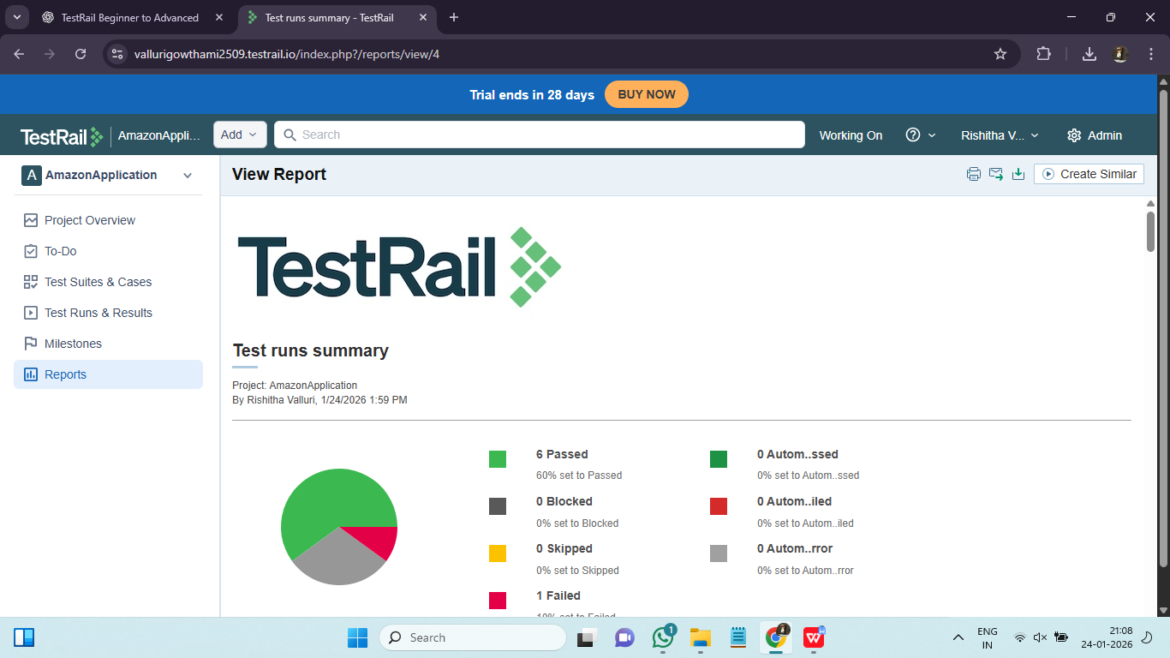

Coverage Reports :

Coverage answers: What requirements / features were tested? We can have 100% coverage with poor execution.

Types of Coverage :
- Requirement → Test Case
- Test Case → Execution
- Feature → Status
Status | Meaning
Covered & Passed | Safe
Covered & Failed | Risk
Not Covered | High risk

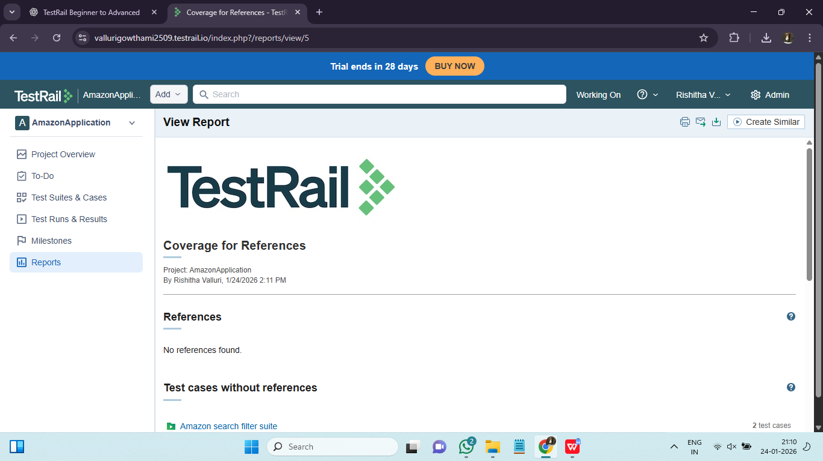

4. Defect Reports :

Shows defects linked during execution. It includes : Count, Status, Distribution. Defect reports help prioritize risk and stabilize releases.

Common Defect Reports :

Defects per Test Run

Defects per Requirement

Defects per Tester

Defect Trends

Metric | Insight
Defect density | Quality of module
Reopen rate | Fix quality
Defect leakage | Test effectiveness

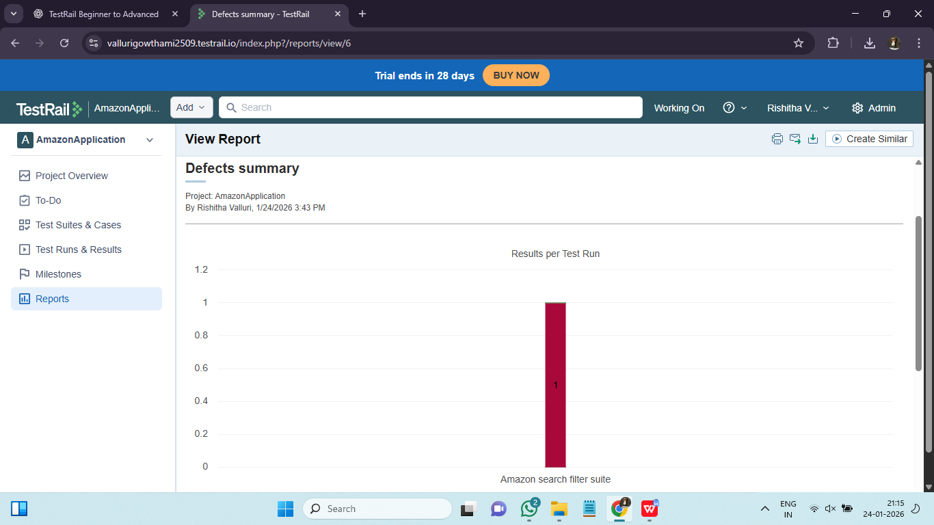

5. Custom Reports :
Custom reports exists because default reports don’t always answer:
- Project-specific KPIs
- Client-specific metrics
- Audit questions

We Can Customize :
- Filters (suite, priority, type)
- Grouping (module, tester)
- Time ranges
- Status combinations
Custom reports align QA metrics with business goals.

6. Dashboards & Widgets :
A dashboard is a real-time visual snapshot of testing health. Dashboards provide at-a-glance release confidence.Widgets show:
- Execution progress
- Pass/Fail ratio
- Defect count
- Coverage trends

Common Widgets :
- Test Results Pie Chart
- Progress Over Time
- Defects Summary
- Coverage Widget
Role | Focus Widgets
Tester | Assigned tests
Lead | Progress + defects
Manager | Release readiness

